TASK 2: API INTEGRATION & JSON HANDLING
Name
Gaddala Sathwik
Internship Domain
Python Developer
Objective
The objective of this task is to fetch data from a public API, parse JSON responses, implement search functionality, and handle API errors using Python.
Tools Used
- Python
- Requests Library
- Visual Studio Code (VS Code)
Program Description
This program fetches user data from a public API using the Requests library. The JSON response is parsed and displayed. A search feature is implemented to find users by name. Exception handling is used to manage API and runtime errors.

Source Code
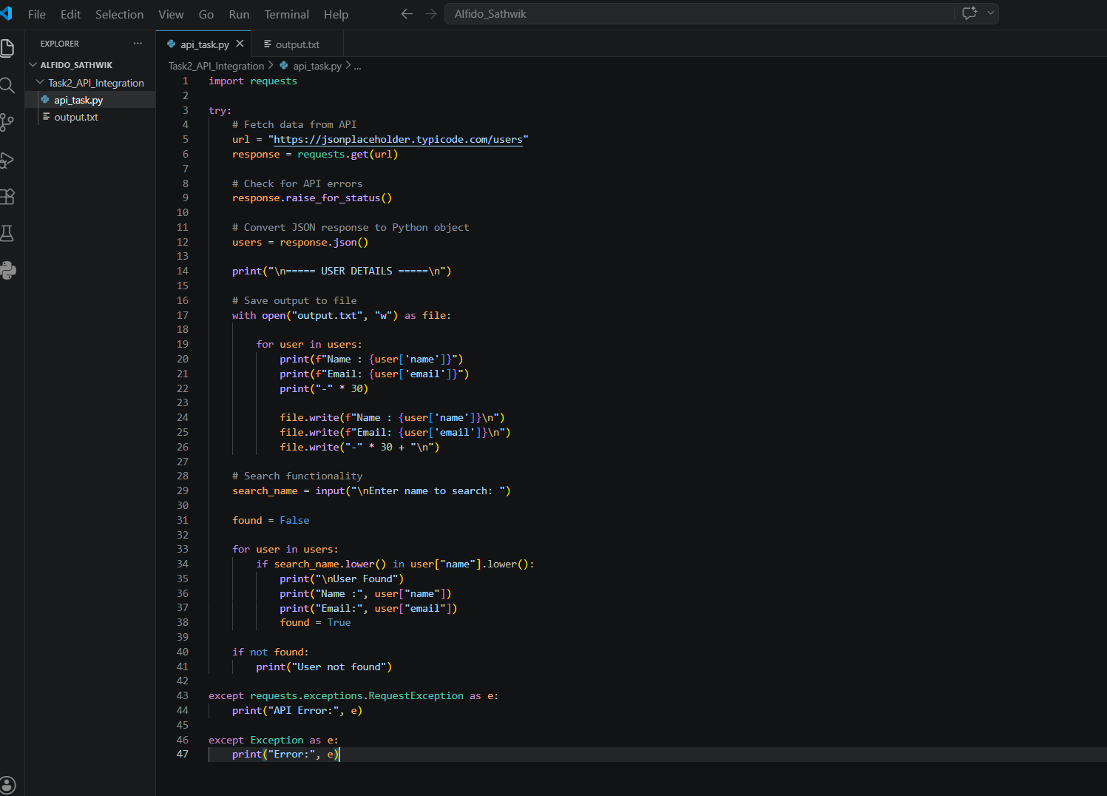

Output Screenshots
Screenshot: Program Execution
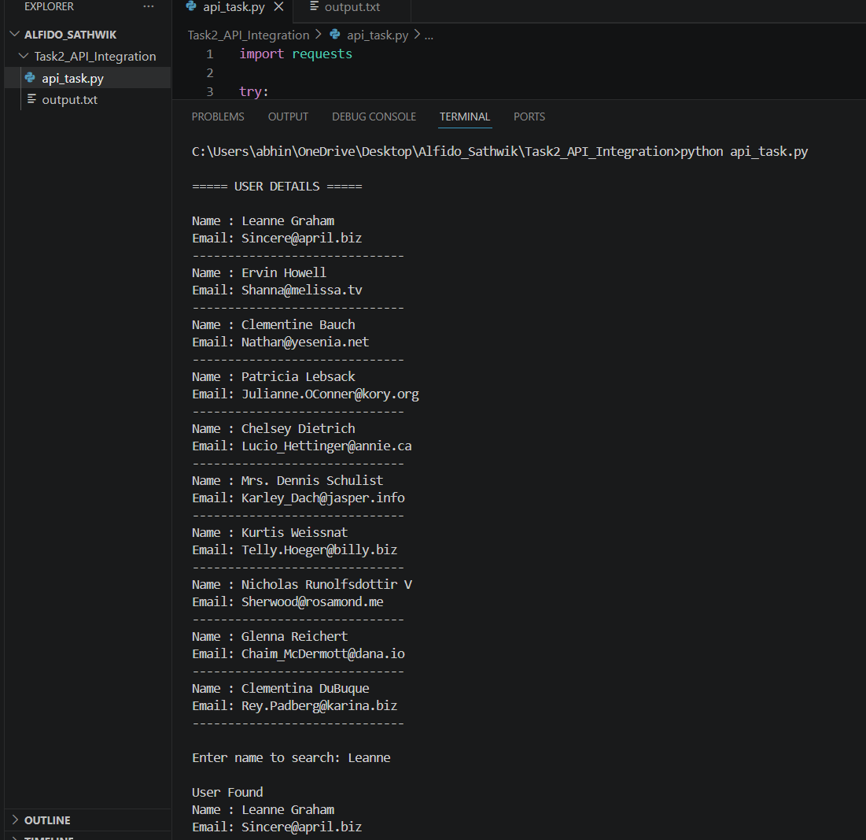

Screenshot: Output File
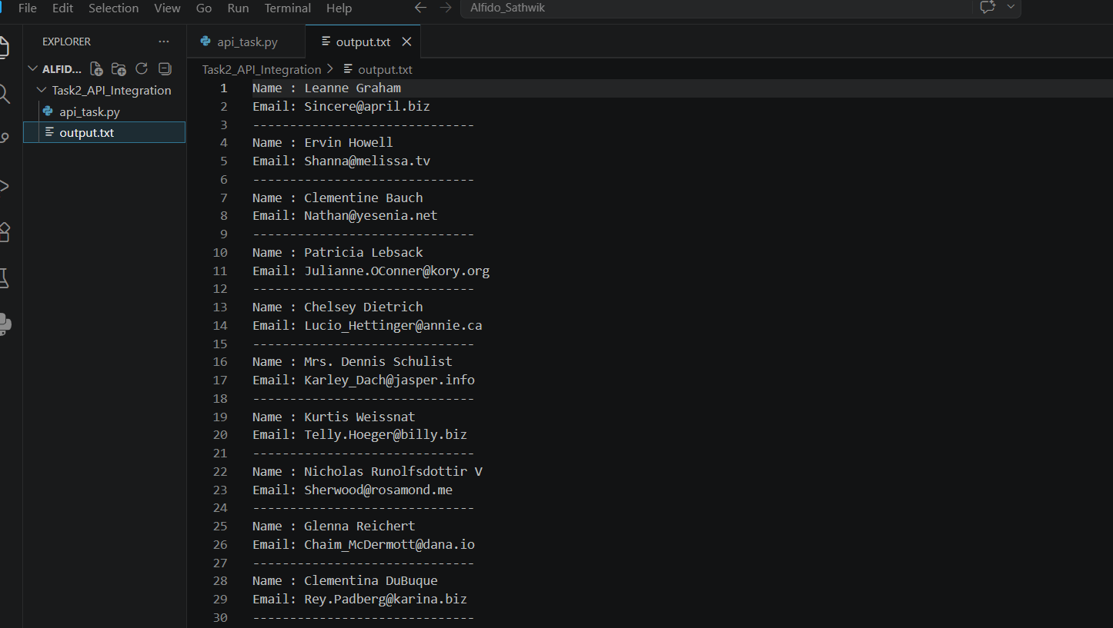
Result
The program successfully fetched data from the API, parsed JSON data, implemented user search functionality, and handled errors effectively.
Conclusion
This task provided practical experience in API integration, JSON data handling, search operations, and exception handling using Python.

